# PRACTICE PROGRAMS MODULE -1

## SECTION : 5

### SECTION-5.2

1A)

PROGRAM :

import java.util.Scanner;

public class Main {

public static void main(String[] args) {

Scanner scanner = new Scanner(System.in);

String[] code = {"", "D", "W", "E", "L", "H", "O", "R"};

System.out.println("Enter 10 numbers to decode the secret message:");

String message = "";

for (int i = 0; i < 10; i++) {

int num;

do {

System.out.print("Enter number " + (i + 1) + ": ");

num = scanner.nextInt();

} while (num < 1 || num > 7);

message += code[num] + " ";

}

System.out.println("Decoded message: " + message.trim());

}

}

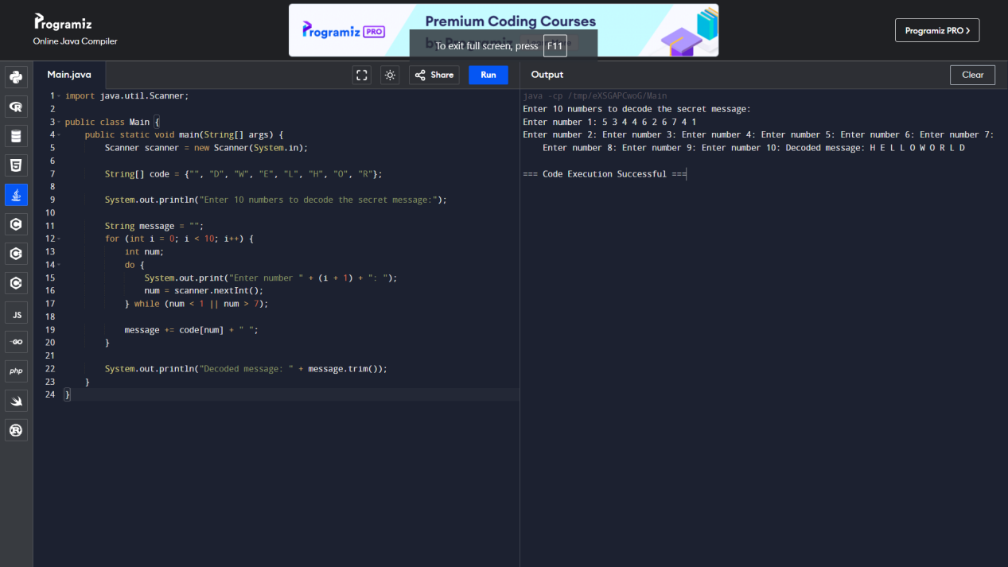

4A)

PROGRAM :

import java.util.Arrays;

public class AnagramChecker {

public static boolean areAnagrams(String str1, String str2) {

// Remove white space and punctuation, and convert to lower case

str1 = str1.replaceAll("[^a-zA-Z0-9]", "").toLowerCase();

str2 = str2.replaceAll("[^a-zA-Z0-9]", "").toLowerCase();

// Check if the sorted strings are equal

char[] charArray1 = str1.toCharArray();

char[] charArray2 = str2.toCharArray();

Arrays.sort(charArray1);

Arrays.sort(charArray2);

return Arrays.equals(charArray1, charArray2);

}

public static void main(String[] args) {

// Example usage:

System.out.println(areAnagrams("parliament", "partial men")); // True

System.out.println(areAnagrams("software", "swear oft")); // True

System.out.println(areAnagrams("hello", "world")); // False

}

}

